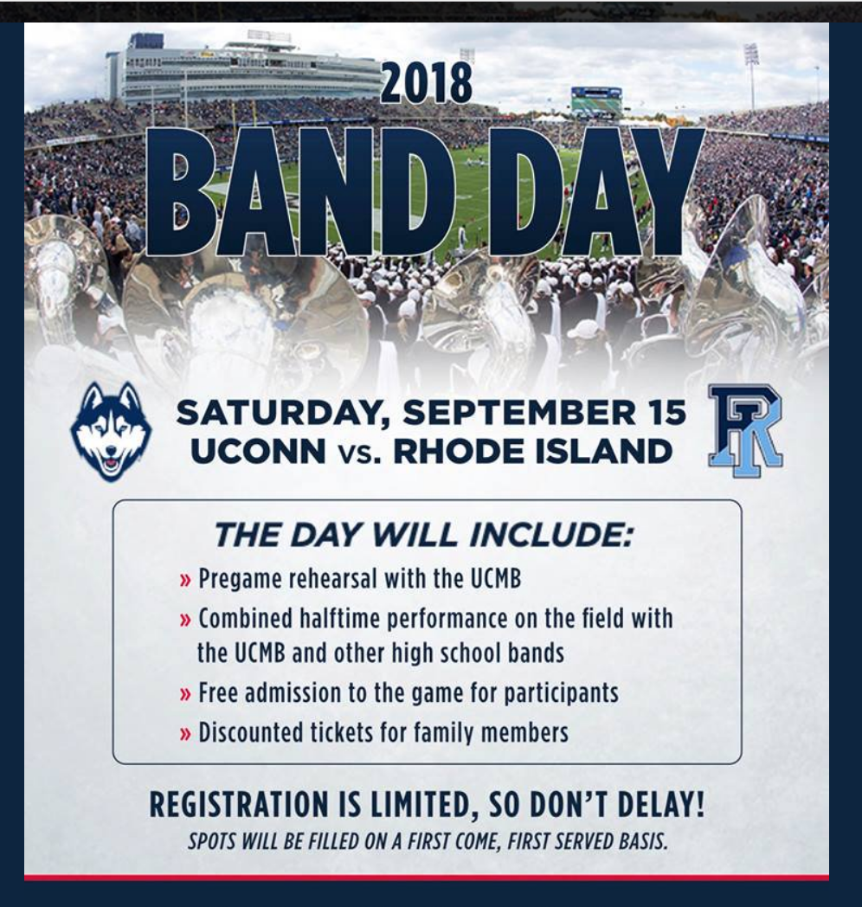
Encourage your families and friends to attend the game at a discounted ticket price of only $20. Simply enter the promo code PARENT2018 at uconnhuskies.com.

